Community Food Initiatives North East

Improving Health and Well-Being: Business for Community Benefit

YOU buy fruit, veg, healthy snacks? For the office, workplace kitchen, events, for domestic purposes? Why not consider CFINE – good produce, price and service and you would be investing in our considerable work for community benefit! ALL profit supports our social and community services and support which focusses on disadvantaged, vulnerable, low income individuals, families and communities in Aberdeen, Aberdeenshire and Moray (FareShare only).

What do we do?
- 65 Community Food Outlets (CFO) making affordable produce accessible to disadvantaged and vulnerable communities.
- 250 volunteers, work placements and supported trainees (adults with learning difficulties) recruited, trained and supported over past year.
- The Fruit Mart, Skelton Street, Peterhead, north Aberdeenshire, supports >20 CFO’s, sells fruit, veg and other produce at the base and has up to 20 adults with learning difficulties in supported training. The Fruit Mart also partners with the Willowbank Centre with additional adults with learning difficulties supported by its staff and a ‘shop and drop’ scheme supporting vulnerable people.
- Education, information and training on e.g. reducing food waste, healthy cooking on a budget, ‘benefits and budgeting’ etc.
- FareShare Grampian where food through the FareShare network is distributed to people in food poverty; the produce is distributed to 180 ‘Community Food Members’ across Aberdeen, Aberdeenshire, Moray.
- FareShare >450 tonnes of produce, saving 1,890 tonnes of carbon emissions, distributed in last year, equates to: 64,000 emergency food parcels; >1,070,000 meals; a (modest) value of >£1,350,000.
- CFINE is the lead partner in the >60 partners-strong Food Poverty Action Aberdeen (FPPA).
- FPPA distributed >30,000 emergency food parcels (equivalent), and other products e.g. toiletries, nappies, sanitary products, through 2017; CFINE’s own food bank >10,000 parcels, on course to distribute >15,000 emergency parcels through 2018.
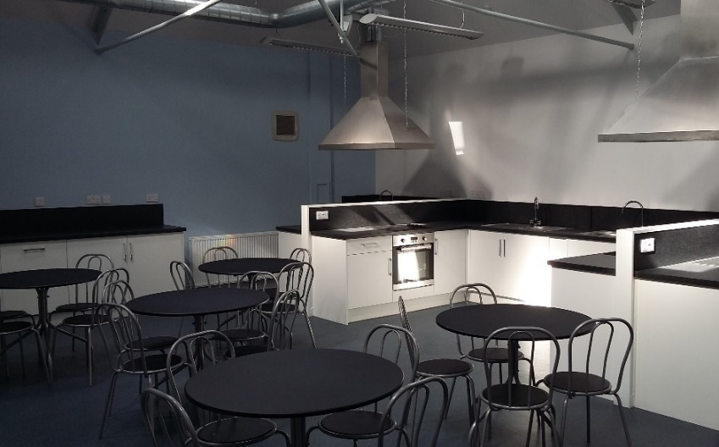
- 23 of 33 employees recruited from our priority communities e.g. unemployed, mental health issues, learning disabilities, addiction.
- Financial capability and education and debt and budgeting information and support. ‘Cash In Your Pocket’ referral service supporting beneficiaries, often with multiple issues, to secure support from the right service.
- Action on environmental issues promoting ‘Zero Waste’ - reuse, reduce, recycle.
- Roots and Shoots project supports ex- offenders through work experience.
- Action Health Education/Employment Against Disadvantage (AHEAD), a partnership between Grampian Housing Association (financial capability and education), Pathways (employability) and CFINE; AHEAD provides a more coordinated, holistic support/services to our priority communities.
- Directly and with support from partners, CFINE offers employability, ‘benefits and budgeting’ and health and well-being support responding to the needs of beneficiaries.
- A Community Training Kitchen (Cook at the ‘Nook) in 2-4 Poynernook Road provides free training to disadvantaged and vulnerable people and offers opportunities for corporate team building, ‘cook school’ classes and rental to generate income.
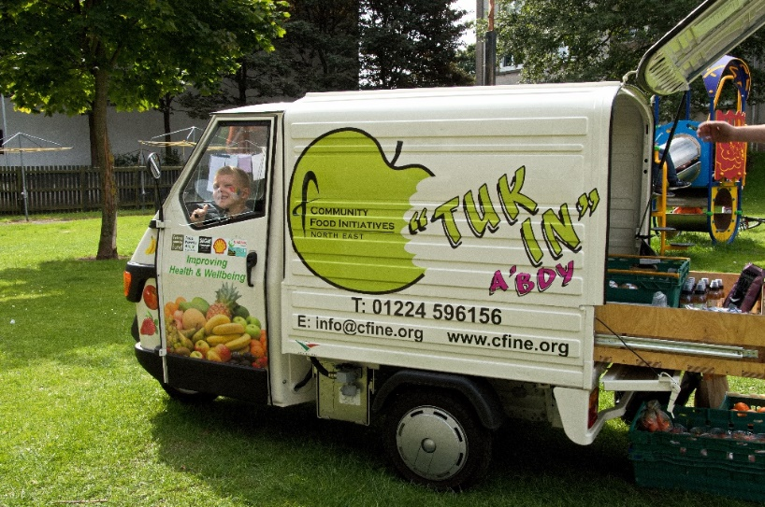
- Member of the Syrian Refugees Action Groups in Aberdeen and Aberdeenshire.
- ‘Tuk In’ (Mobile Community Café), an innovative development using a tuk tuk to promote healthy eating and reduce food waste. Available to
- CFINE supports ‘Aberdeen Community Food Network’, promoting food skills training, >40 partners.
- CFINE hosts Sustainable Food City Partnership Aberdeen’s Coordinator who will also be developing the ‘Veg City’ initiative (SFCPA@cfine.org).
- CFINE ran an ‘Access to Free Sanitary Products’ pilot on behalf of The Scottish Government, evaluating same resulting in the roll out of a national scheme in Scotland (first country in the world). CFINE’s FareShare Grampian distributes product to low income people in Grampian and is facilitating distribution in Orkney, Shetland and Inverness.
- Aberdeen Council agreed its ‘Community Growing Strategy’ including allocating finance so CFINE could employ a development officer to support its implementation (communitygrowingaberdeen@cfine.org).
- Re produce, CFINE purchases locally whenever possible to contribute to the local economy and the environment through reducing food miles.
- CFINE’s enterprise company sells commercially and competitively wholesale and retail fruit, veg, eggs, pulses, healthy snacks. ALL profit is invested in our work for community benefit. THINK FRUIT and VEG, THINK CFINE! Enterprise income also generated through the ‘Nook, Tuk In and rental of office space.
- Recently, CFINE’s CEO was appointed as Food Power’s Scotland Mentor, in essence supporting anti-food poverty alliances within Scottish local authority areas to develop strategies and action plans and learn from each other to try to ensure people have dignified and fair access to food.

Want more information including how to buy YOUR fruit, veg, pulses, eggs and healthy snacks from CFINE, then contact CFINE - 01224 596156/ info@cfine.org/ www.cfine.org

Thank you,
Dave Simmers, CEO

Tackling Poverty: Building Resilience

Volunteer Case Studies
NB photographs do not represent those identified in the case studies.

Case Study 1
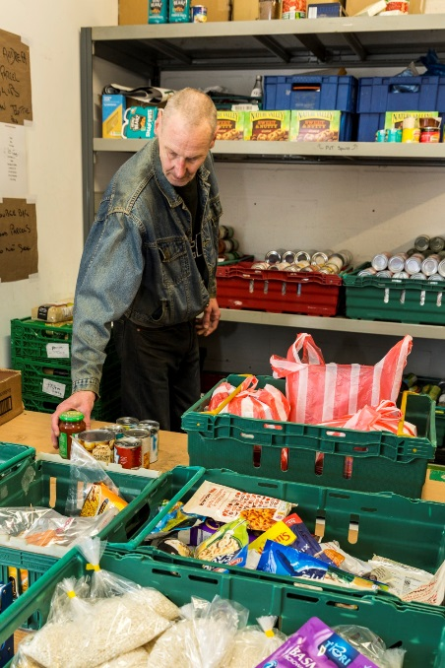
Mr. M is a volunteer at CFINE and had been in receipt of PIP for less than a year before he had his claim reassessed in January and was unsuccessful. Mr. M had his PIP payments stopped without warning. He has Parkinson’s disease and there has been a substantial decline in his ability to speak. He was very distressed at the decision – he had been judged not to be entitled based on the number of “points” he had scored on his assessment did not meet the threshold. He told me that he felt like he was having to prove his illness, and this was both degrading and humiliating.
Mr. M then approached the CFINE Financial Capability Officer for help and we submitted a mandatory reconsideration which was unsuccessful in getting his claim reinstated. We referred him to the Financial Inclusion Team for appeal. He was told by the DWP in April that he would not have to go through with the appeal and he was awarded PIP of £55.10 until 2025. Mr M was still not in receipt of payment two months after this decision and he has faced delays throughout the whole process often waiting months at a time for correspondence from the DWP.
He tells me that the whole experience was very distressing. As with many other clients, he would receive a response letter a couple of weeks before the final due date for an appeal – thus leaving very little time to prepare medical evidence (as it often takes more than this amount of time to get an appointment).

Case Study 2
Miss R started volunteering at CFINE in 2015 when she was seventeen. She was very quiet, unconfident, and rarely spoke to other staff members or volunteers. She was dealing with an on-going mental health issue and her mum had suggested that she start helping out at CFINE as a way to build confidence and benefit from working in a team and building social relationships.
Over a number of months, the team noticed a huge difference in Miss R. She really began to open up and could be seen laughing and joking with other volunteers. Since she gained employment running a CFO, she has gone from strength to strength and really feels part of the team. When I asked her how her time has been at CFINE, she summed it up simply: “I feel happy now”.
Update: Miss R has now moved into employment as a care assistant and is going from strength to strength.

Case study 3
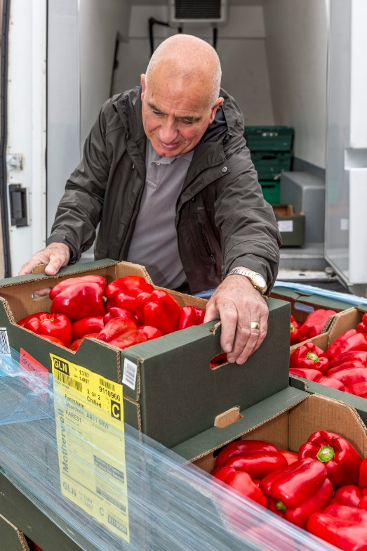
B was drug dependent, had had a good job, wife and family and lost it all through drug use. He came to CFINE dirty and dishevelled, had come off drugs but was struggling in every sense, no money, struggling to ‘stay clean’ etc. He came to get emergency food and the staff member suggested that he should return because he was in a bad way. B returned for more produce and in discussion with the staff member, she suggested he come in as a volunteer to give him a purpose, a reason to get up, stay ‘clean’ etc. He is now office based within CFINE and gives up 18hrs a week of his time; B helps in the food bank but also inputs data re food bank usage, a valuable contribution to CFINE’s operation.
B’s confidence has grown since his involvement with CFINE, he is always in when he says he will be and now very confident of the task he is undertaking. B is now clean and tidy, looks and feels healthier, has a sense of purpose and is looking forward to a brighter future including securing employment – something a few months ago was simply not tenable. He has also completed an ‘Environmental Awareness and Healthy Eating’ course.
In addition, B delivered a speech to delegates at the ‘Feeding Aberdeen Seminar’. His presentation was inspirational and uplifting. General consensus in the room was that he stole the show! This demonstrated how far B has come in terms of his confidence. In his speech he mentioned that he is facing problems with his council tax arrears; a problem that was quickly rectified by Aberdeen City Council delegates present – for which he was appreciative.
Subsequently, B has been offered training from Aberdeen City Council in money advice/budgeting and an overview of welfare changes, so that he can help those who find themselves in the same situation that he did.

Case study 4
Mr D started volunteering for CFINE in April 2015. Mr D is autistic and had low self-esteem when he started. He worked in the warehouse making up orders, sorting stock, and more importantly interacting with fellow volunteers and workers. In time his confidence grew and he became more willing to take on different roles within CFINE.
With the appropriate support, Mr D moved on to a driving role, which included deliveries and pick-ups. This opportunity boosted his confidence further and he became good friends with a number of team-mates. His cracking sense of humour, kindness to others, and hard work contributed to him becoming a much valued and respected member of the team.
Mr D has since achieved employment here at CFINE and works as a driver/store person, contributing to the large quantities of food distributed to organisations throughout the city.
“I really enjoyed volunteering at CFINE delivering food to all the CFMs. I think it really helped me make friends and become one of the team. When I got told that I could do it as a paid job I was very happy!”

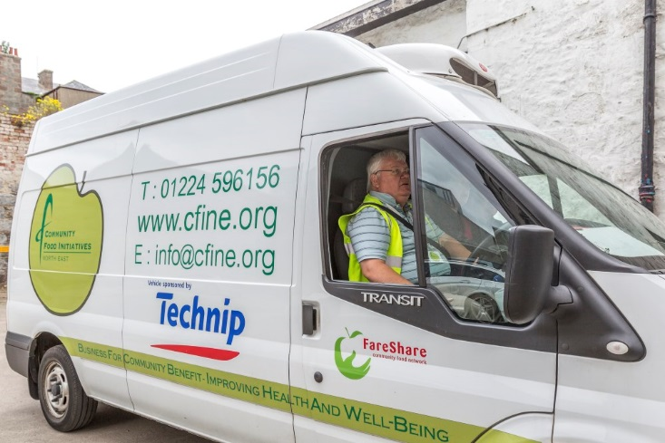

Volunteer driver

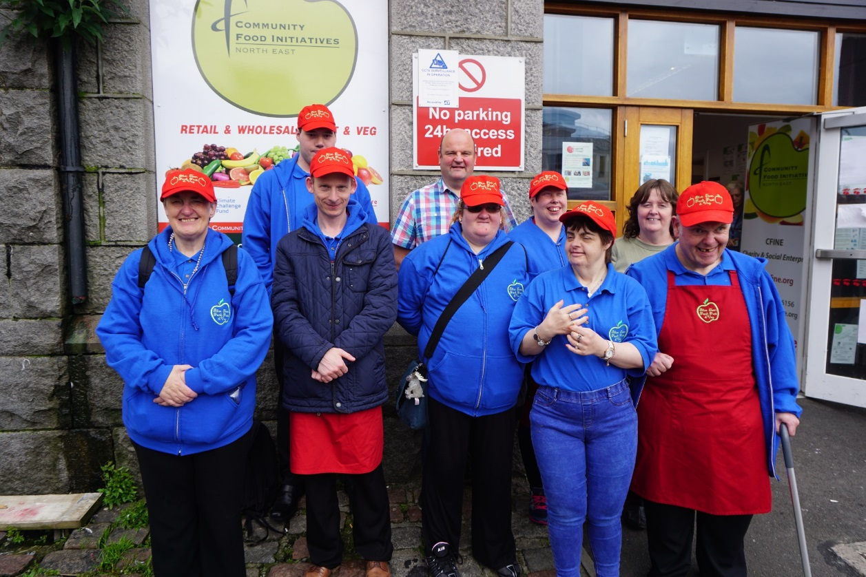
Cooking event with Fruit Mart Adults w/ learning difficulties from the Blue Toon!

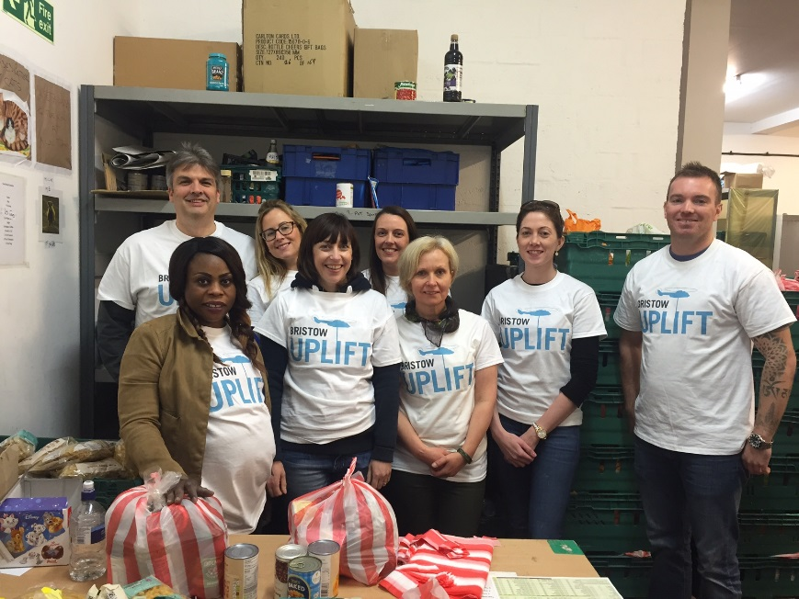
Corporate volunteering w/ Bristow Uplift

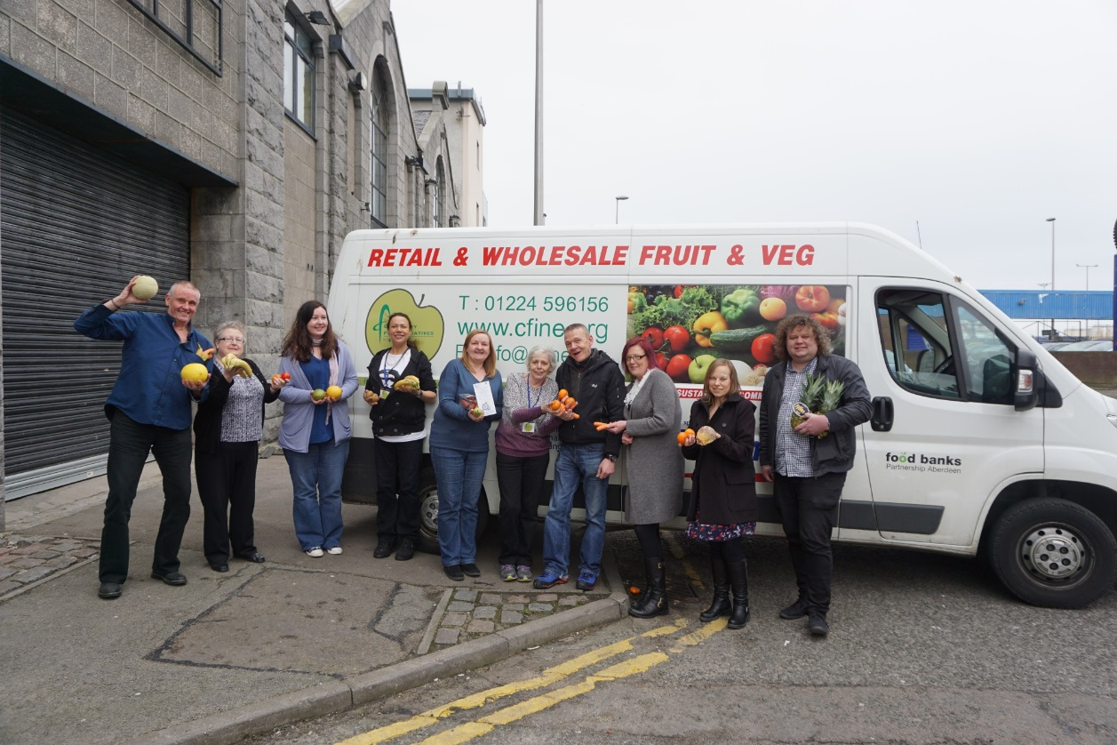
CFINE staff

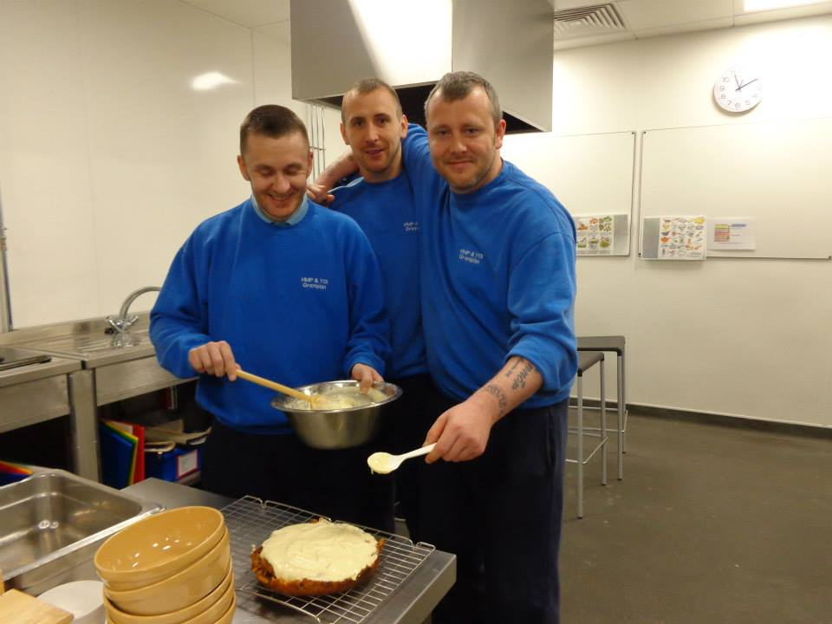
HMP Grampian cooking session

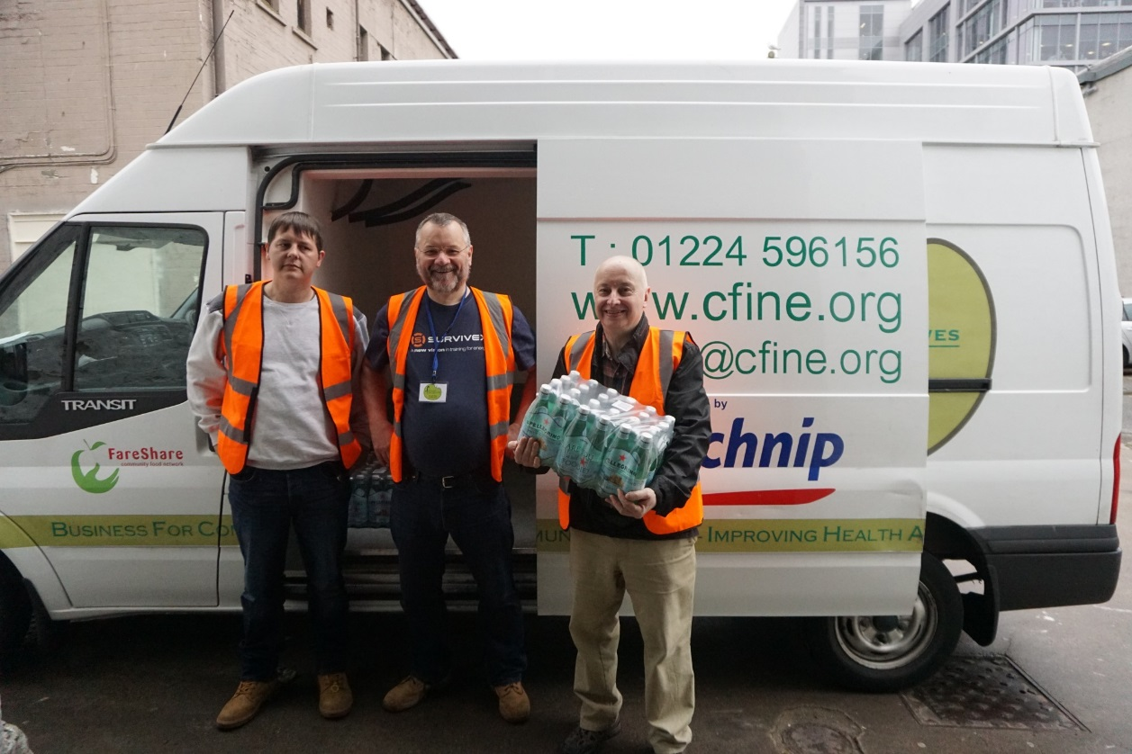

Lord Provost (right) volunteering day

Social work student placement – Manor Park School

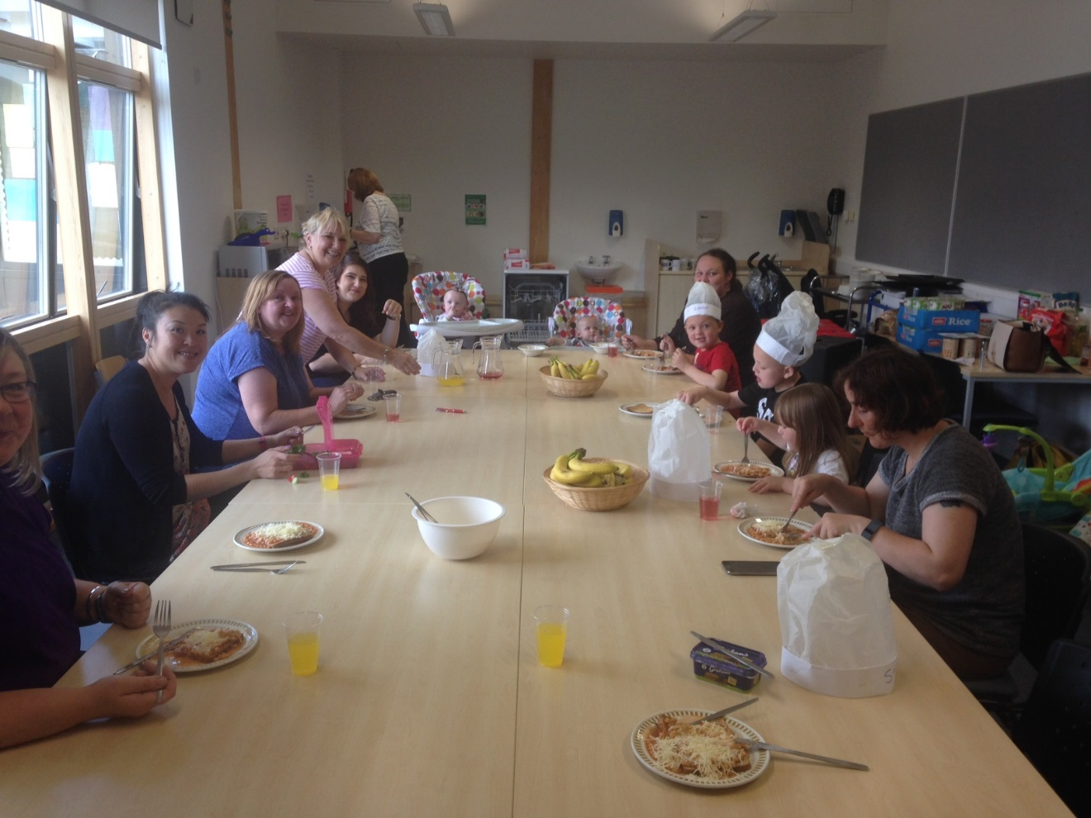
Manor Park – group lunch

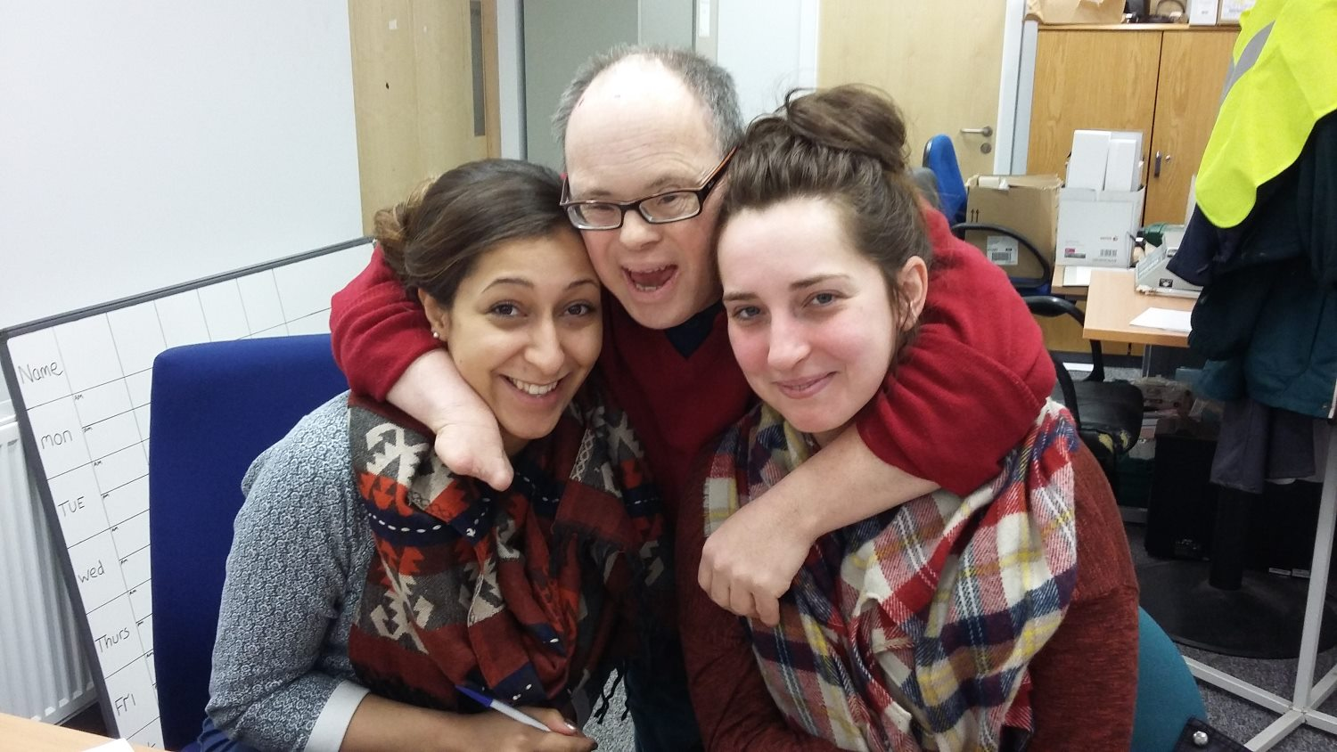
Students on placement, getting on well with Grant (centre) who volunteers once a week.

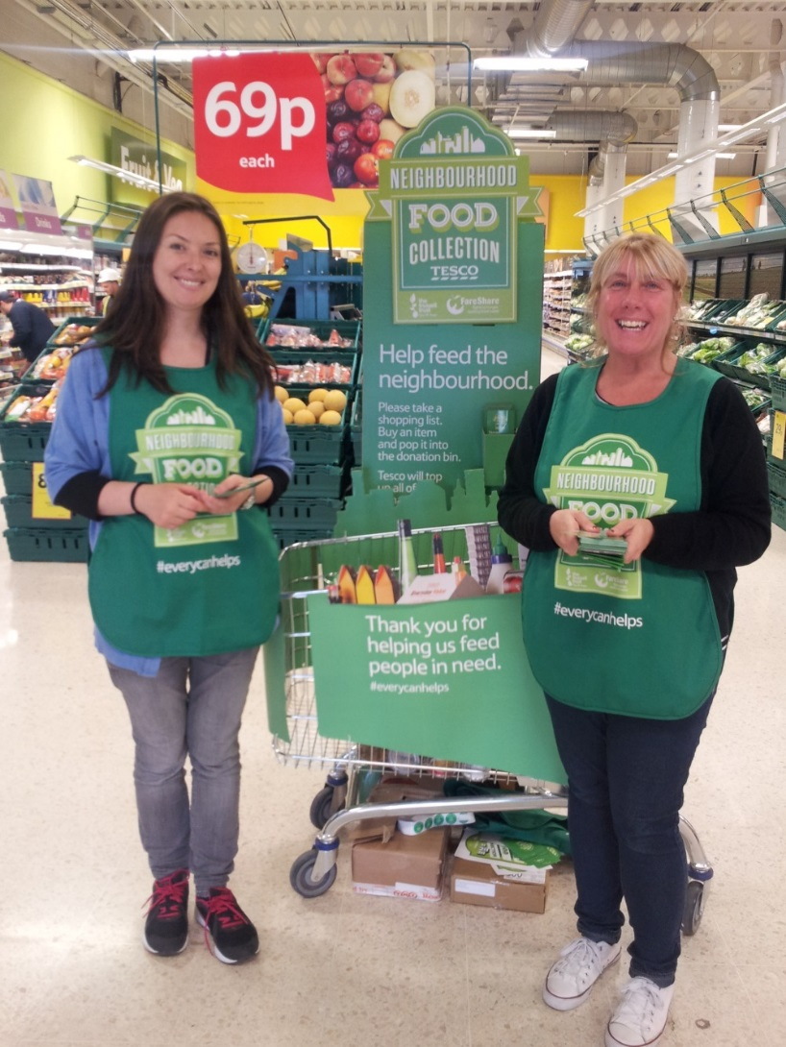
Volunteer’s collecting at the bi-annual Neighbourhood Food Collection

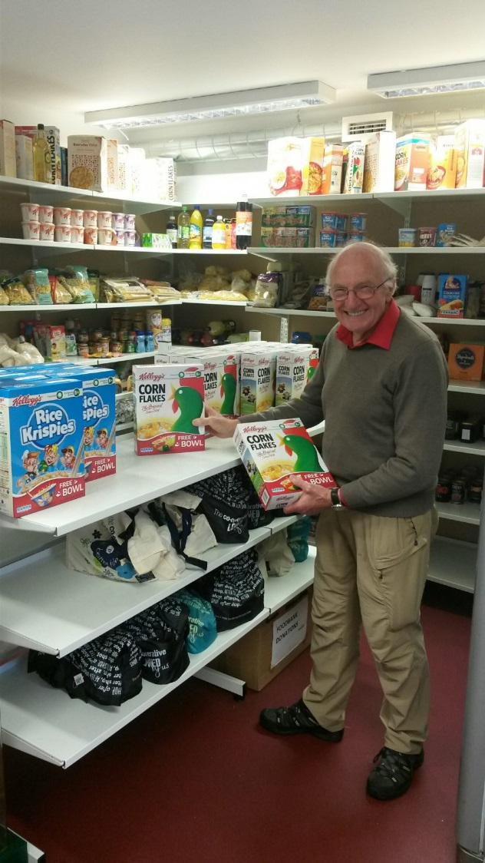
Food bank volunteer

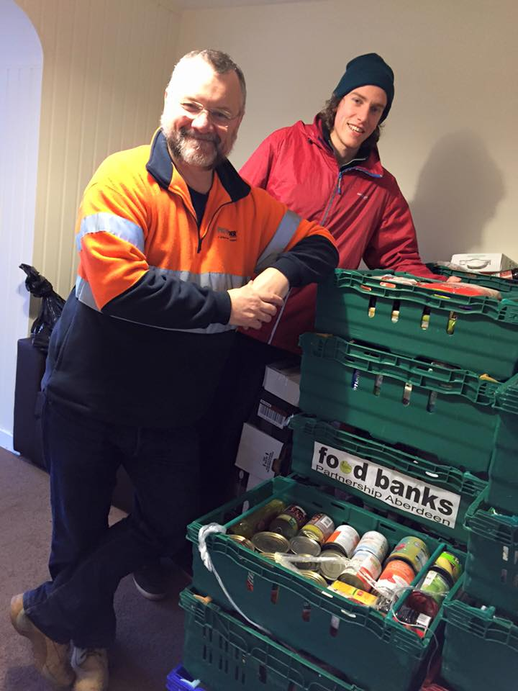
Delivering to Syrian Refugees

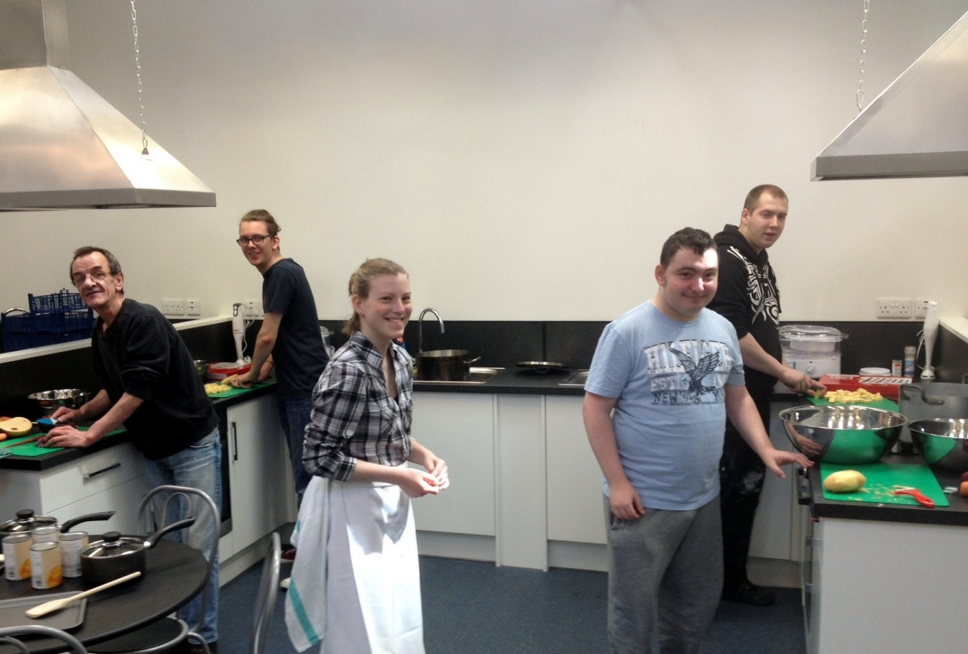
Cooking with “waste food” session with volunteers

